For Information / Consideration / Comment / Decision (delete as appropriate)
Public/Non Public*
Report to: | Accountability Board
Date of Meeting: | 9 August 2022
Report of: | Mark Kimberley
Report Author: | Tracey Morris
E-mail: | tracey.morris@notts.police.uk
Other Contacts: | Danny Baker
Agenda Item:

Chief Constable’s Revenue Outturn Report 2022/23 as at the end of June.

- Purpose of the Report

  - The purpose of this report is to provide the financial outturn position for revenue for 2022/23 as at the end of June for the Chief Constables accounts.

- Recommendations

  - Recommendation 1
It is recommended that the contents of the report are noted.

- Reasons for Recommendations

  - To update the Force Executive Board on the Force’s outturn position for 2022/23 as at the end of June, and to comply with good financial management and Financial Regulations.

- Summary of Key Points

  - The revenue budget is £236,431k, outturn at the end of 2022/23 is currently forecast to be on budget.

4.2 Summary of budget by spend type.
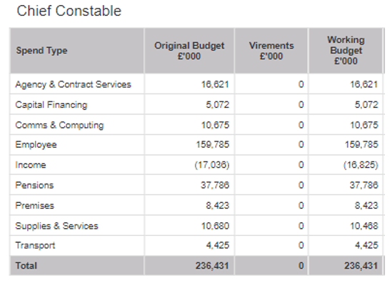
4.3 Several unexpected, unbudgeted items have been brought our attention during quarter 1 of the financial year. These are detailed in section 5.
5 Financial Implications and Budget Provision

5.1 Increase in Officers.
The budget was approved and costed to account for an FTE establishment of 2,337 by 31st March 2023.
An additional 31 officers will be recruited as part of Government’s 20,000 uplift, this will be funded through a grant of £620k.
As the officers will start towards the end of the year, the balance on the grant will be carried forward into 2023/24 to off-set the additional costs that will impact on that year.
In addition to this the Chief Constable will recruit an additional 19 officers (bringing forward recruitment from 23/24) this will mean a total of 50 additional officers in 2022/23, we will use the above grant to fund these officers, along with associated uniform and IT costs.
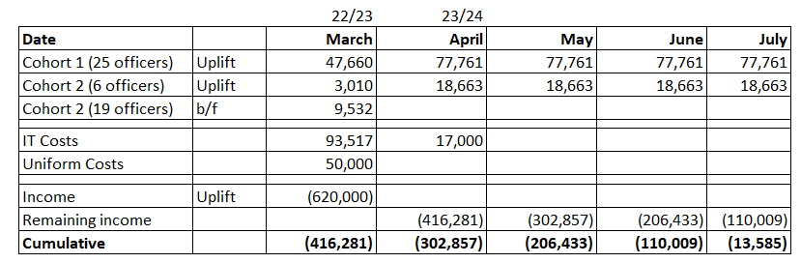

5.2 Pay Awards
Within the budget a Police Officer pay award was included of 2%, confirmation has been received that each scale point will be increased by £1,900 per annum, effective 1st September 2022. This increase has been calculated to an across-the-board average increase of 5.1% for all officers.
The financial impact on 2022/23 will be around an extra £3.85m of which the force will receive funding of £1.25m, thus creating an in-year shortfall of £2.6m.
If we assume, for now, an additional 1.5% that staff may get from September this would add a further £0.5m of cost that is unlikely to be funded.
In total an additional cost of £3.1m to find in year.
5.3 Overtime
In 2021/22 it was reported that a cost of £1,326k was incurred at the end of the year in respect of the unpredictable nature of Police Officer elected bank holidays, it is anticipated that the force will incur a similar cost this financial year. As the cost was not identified until after the budget for 2022/23 was agreed and published it has not been included, it is expected a cost of £1,200k could be incurred, some of the cost from 2021/22 was off set with mutual aid income.
5.4 Inflation
A safeguard against increased fuel rises was built into the budget, however current information would suggest that these costs will rise above the safeguard budgeted.
Across gas, electric, petrol and diesel this amounts to an unbudgeted cost of £751k.
5.5 Insurance
The Insurance premiums have been renewed for the financial year. This shows an increase in costs of £724k. Some of this could be offset against reducing the contributions to the insurance provision.
5.6 Staff Pay
A staff vacancy rate of 3% was built into the budget allowing for a percentage of staff posts to be vacant during the year. We are expected to underspend by a further (£2,500k) due to high staff turnover and difficulty in recruiting to vacant posts.

5.7 Grant Income
Performance Uplift grant of (£2,400k) will be received at the end of the financial year.
5.8 Summary
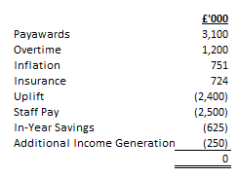
6 Human Resources Implications

  - We are expected to underspend by a further (£2,500k) due to a high staff turnover and difficulty in recruiting to vacant posts.

  - The impact is more heavily felt within the Enabling Services areas of the force and will impact on the delivery of change programmes as well strategic activities which may take longer to deliver.

  - Short term operation issues will/have occurred in the delivery of day to day business, particularly in respect of bedding new systems into the organisation and resolving early life issues.

  - These issues will need to be carefully managed throughout the year.

- Equality Implications

7.1 There are no equality implications arising from this report.
- Risk Management

8.1 There are no risk management implications arising from this report.

- Policy Implications and links to the Police and Crime Plan Priorities

9.1 There are no policy implications arising from this report.

- Changes in Legislation or other Legal Considerations

  - There are no changes in legislation or other legal considerations that are relevant to this report.

- Details of outcome of consultation

  - The figures included in this report are presented to the Force Executive Board monthly.

12. Appendices

  - There are no appendices to report.

13. Background Papers (relevant for Police and Crime Panel Only)

NB: See guidance on public access to meetings and information about meetings for guidance on non-public information and confidential information.

