NOT PROTECTIVELY MARKED – for public release | Agenda Item No.
10

JOINT INDEPENDENT AUDIT COMMITTEE
23 November 2023

Subject | Treasury Management Mid Year Report 2023/24
Report by | CC CFO & PCC CFO
Contact officer | Liam Kerry  liam.kerry@notts.police.uk
SUMMARY AND PURPOSE OF REPORT

To present the treasury management interim report 2023/24 as at 30th September 2023.
RECOMMENDATION | That the Committee note the report.

A. SUPPORTING INFORMATION

The PCC is required by regulations issued under the Local Government Act 2003 to report on its Prudential Code indicators and treasury activity. This report meets the requirements of both the CIPFA Code of Practice on Treasury Management (the Code) and the CIPFA Prudential Code for Capital Finance in Local Authorities (the Prudential Code).
Members are invited to review the treasury management interim report 2023/24 attached at Appendix 1.

B. FINANCIAL CONSIDERATIONS

There are no additional financial implications to those contained in the appendices.
C. LEGAL AND HUMAN RIGHTS CONSIDERATIONS

None.

D. PERSONNEL, EQUAL OPPORTUNITIES AND DIVERSITY ISSUES
(including any impact or issues relating to Children and Young People)

None.

E. REVIEW ARRANGEMENTS

The forward plan sets out the items that JIAC will review and note regarding Treasury Management, as set out below:
- An Annual Treasury Strategy in advance of the year.
- A Mid-Year Treasury Update Report (Appendix 1).
- An Annual Review following the end of the year describing the activity compared to the Strategy. (This is planned for May 2024).

F. RISK MANAGEMENT

The management of risk is an integral part of the code of governance and the
annual governance statement. The TM mid-year review is a key review document in the governance framework.

G. PUBLIC ACCESS TO INFORMATION

Information in this report along with any supporting material is subject to the Freedom of Information Act 2000 and other legislation.

Appendix 1

Public/Non-Public*
Report to: | PCC
Date of Meeting: | 13th November 2023
Report of: | Mark Kimberley
Report Author: | Alison Denny
E-mail: | Mark.Kimberley1@notts.police.uk
Other Contacts: | Liam Kerry
Agenda Item: | N/A

Treasury Management Interim Report 2023/24 as at 30th September 2023.

- Purpose of the Report

The purpose of this report is to provide the performance monitoring of the 2023/24 Prudential Code Indicators to the Police and Crime Commissioner (PCC).
Regular reporting of Treasury activity is required in line with the Treasury Management Strategy, and this report meets these requirements.

- Recommendations

  - Recommendation 1
It is recommended that the contents of the report are noted.

  - Recommendation 2
It is recommended that this report is forwarded to the Joint Independent Audit Committee for their review and comment.

- Reasons for Recommendations

  - To update the PCC on the Treasury Management activities in compliance with the Treasury Strategy.

- Background

The Organisation is required by regulations issued under the Local Government Act 2003 to report on its Prudential Code indicators and treasury activity. This report meets the requirements of both the CIPFA Code of Practice on Treasury Management (the Code) and the CIPFA Prudential Code for Capital Finance in Local Authorities (the Prudential Code).

  - For 2023/24 the minimum reporting requirements are that the PCC should receive the following reports:
- An Annual Treasury Strategy in advance of the year.
- A Mid-Year Treasury Update Report (this report).
- An Annual Review following the end of the year describing the activity compared to the Strategy. (This is planned for May 2024).
In accordance with best practice, regular updates on treasury activity are also provided to the PCCs Chief Financial Officer (CFO).
  - The regulatory environment places responsibility on the PCC for the review and scrutiny of treasury management policy and activities, this duty is supported by further review by the Joint Independent Audit Committee (JIAC). This report provides details of the position at 30th September 2023 and highlights compliance and non-compliance with the approved Strategy.

- Treasury Activity

5.1 Investments
During the first half of the year, we saw Interest rates rise by a further 100bps, taking Bank Rate from 4.25% to 5.25% and, possibly, the peak in the tightening cycle. The Authority has a new positive investment position as a result of the timing of the Council Tax Freeze & Support Grants.
Due to improved budget monitoring, a high pension grant as a result of the increase in Police Officer numbers the organisation has significantly larger cash funds than previous years, and interest rates have continued to climb.

The Commissioner held £80.5m of investments as at 30th September 2023 (£53.3m at 31 March 2023) and the weighted investment portfolio yield for the first six months of the year is 4.07% against the original benchmark of 4.90%. The yield is currently below the benchmark due to a number of fixed investments with Local Authorities that were in place prior to the uplift in interest rates. With these investments omitted from the calculation, the yield rises to 5.04%. The investments at the lower rates have now matured, so the overall yield will increase for the rest of the year.

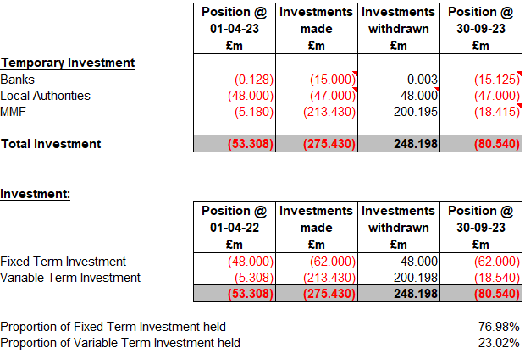

One of the investment types employed by the Commissioner are Low Volatility Net Asset Value Funds (LVNAV). These are used because they are highly rated (AAA), and they work by spreading the investments over a wide range of high-quality counterparties that would be unavailable at the levels of investment monies available. This approach also helps to eliminate risk whilst maintaining liquidity.

They also have the advantage of being easy to manage via an online platform and are liquid to meet cash flow demands. Currently 4 are being utilised and a recent increase in the deposit capacity has been approved in the revised Treasury Strategy. Fixed term investments are with other local authorities or Banks which are also considered to be low risk. The interest rate on current account balances with Barclays is zero.

The new limits in the investment policy for LVNAVs were approved in August 2023 and these have increased to £15m, and £20m with the consent of the PCC CFO. (Previously these were £12m, and £15m). Prior to these new limits being agreed we sought approval to use the maximum limit of £15m across all 4 funds, for the month of July. This was due to the Pension top up grant of £40m being received w/c 3rd July, Police Grant and Precept due £22m, and several investments circa £32m maturing during July. There were in total 23 days when a LVNAV fund balance was over £12m and up to £15m.
No other approved limits have been exceeded.
5.2 Investment Counterparty criteria
The Commissioner’s investment policy has regard to Department for Levelling Up, Housing and Communities (DLUHC) and the revised CIPFA Treasury Management in Public Services Code of Practice and Cross Sector Guidance Notes (“the CIPFA TM Code”). The continuing potential for a re-emergence of a Eurozone sovereign debt crisis together with other risks which could impact on the creditworthiness of banks, prompts a low-risk strategy. Therefore, the Commissioner’s investment priorities in order of importance will be security, liquidity and return.

The maximum exposure to the investment markets in the year to date was on 11th July 2023, when £108.1m (as a result of Police Grant, Top-Up Grant, Pensions Grant and Precept) was placed within the markets.

5.3 Creditworthiness policy

The Chief Constables (CC) CFO will maintain a counterparty list in compliance with the following criteria and will revise the criteria and submit them to the PCC for approval as necessary. The minimum rating criteria uses the lowest common denominator method of selecting counterparties and applying limits, the table below is the current list used during the reporting period covered by this report.

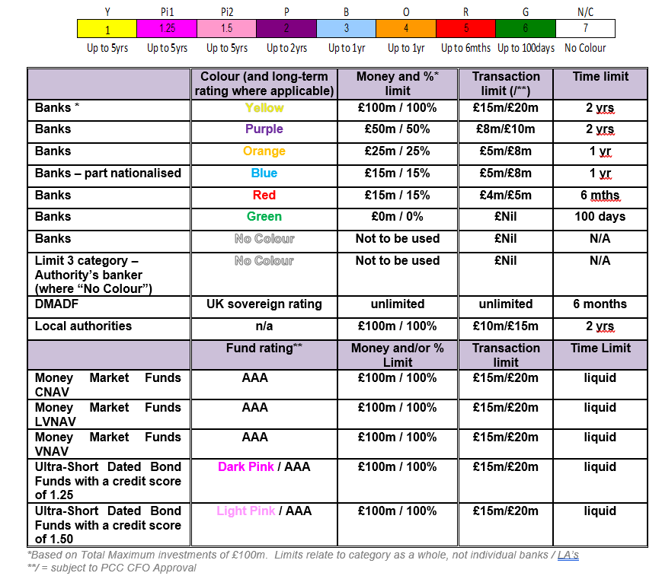

5.4 Borrowing

The Capital Financing Requirement (CFR) for 2023-24 is estimated to be £62.8m. The CFR denotes the underlying need to borrow for capital purposes. If the CFR is positive monies may be borrowed (external borrowing) or from internal balances on a temporary basis (internal borrowing). The balance of external and internal borrowing is generally driven by market conditions and level of reserves. The table below shows activity on borrowings to 30th September 2023.
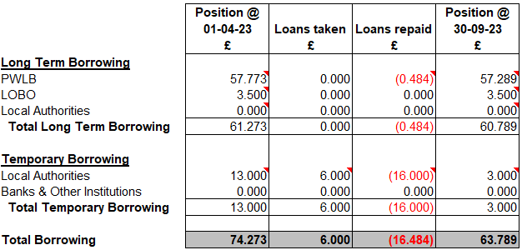

By the year end it is anticipated that there will be external borrowing of £63.2m compared to the current CFR of £62.8m, £85m being the operational limit for borrowing as detailed in the Treasury Management Strategy.

The actual amount borrowed, and the timing thereof is at the judgement of the CC CFO with due regard to market conditions. There has been no PWLB or other long-term borrowing in 2023/24 up to 30th September 2023 and it is not expected that any additional borrowing will be undertaken during the remainder of the financial year.

PWLB certainty rates were on a generally rising trend throughout the first half of 2023/24. At the beginning of April, the 5-year rate was the cheapest part of the curve and touched 4.14% whilst the 25-year rate was relatively expensive at 4.58%.

July saw short-dated rates peak at their most expensive. The 1-year rate spiked to 6.36% and the 5-year rate to 5.93%. Although, in due course, short-dated rate expectations fell, the medium dates shifted higher through August and the 10-year rate pushed higher to 5.51% and the 25-year rate to 5.73%. The 50-year rate was 4.27% on 5th April but rose to 5.45% on 28th September.

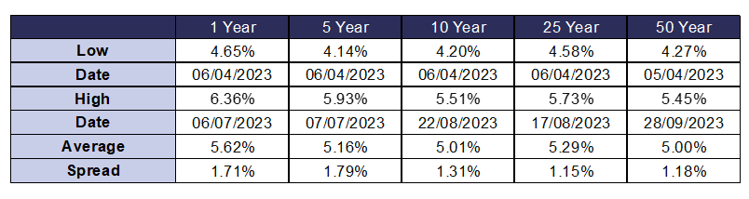

6. Review of Minimum Revenue Provision Policy Statement

6.1 Introduction

The Organisation repays each year part of the accumulated capital spend (CFR) through a revenue charge (MRP). An additional voluntary payment may also be made (VRP). The MRP can be calculated in various ways, but the overarching principles are that the repayment must be prudent and affordable.

6.2 The Stated Policy

The existing policy was approved by The Commissioner and is as follows:
The Commissioner will set aside an amount for MRP each year, which is deemed to be both prudent and affordable. This will be after considering statutory requirements and relevant guidance from DLUHC.

Repayments included in annual PFI, or finance leases are applied as MRP.

It is considered that this policy is both prudent and affordable, therefore no changes are proposed.

7. Human Resources Implications

7.1 There are no immediate Human Resource implications arising from this report.

8. Equality Implications

8.1 There are no equality implications arising from this report.

9. Risk Management

9.1 There are no risk implications arising from this report.

10. Policy Implications and links to the Police and Crime Plan Priorities

10.1 There are no policy implications arising from this report.

11. Changes in Legislation or other Legal Considerations

11.1 There are no changes in legislation or other legal considerations that are relevant to this report.

12. Details of outcome of consultation

12.1 Not applicable.

13. Appendices

13.1 Not applicable.

14. Background Papers

14.1 Finance Working Papers

