For Information
Public/Non Public* | Public
Report to: | Accountability Board
Date of Meeting: | 12th July 2022
Report of: | Mark Kimberley
Report Author: | Tracey Morris
E-mail: | Tracey.morris@notts.police.uk
Other Contacts: | Danny Baker
Agenda Item:

Revenue Outturn Report 2021/22

- Purpose of the Report

  - The purpose of this report is to provide the financial outturn position for revenue for 2021/22.

- Recommendations

  - Recommendation 1
It is recommended that the contents of the report are noted.

- Reasons for Recommendations

  - To update on the Force’s outturn position for 2021/22 and to comply with good financial management and Financial Regulations.

- Summary of Key Points

4.1 The revenue budget is £233,299k, outturn at the end of 2021/22 is £231,689k, generating an underspend of (£1,610k). Which represents an expenditure rate of 99.4%.

4.2 The split between OPCC and Force is shown below.
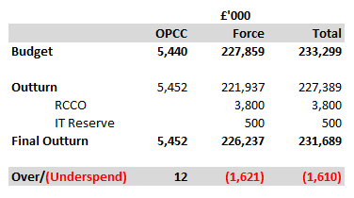

4.3 The Force has an underspend of £1,621k which is detailed in section 5 below. The above table shows a £3,800k RCCO (Revenue Contribution to Capital Outlay), this is a culmination of original budget, sale of write off vehicles (see decision record 2021.088) and in year opportunities to reduce future capital expenditure. £500k is allocated to the IT Reserve to off-set future years costs where supply chain issues will cause an unbudgeted impact.

4.4 Force summary by spend area:
Virements have been reported and approved throughout the year.

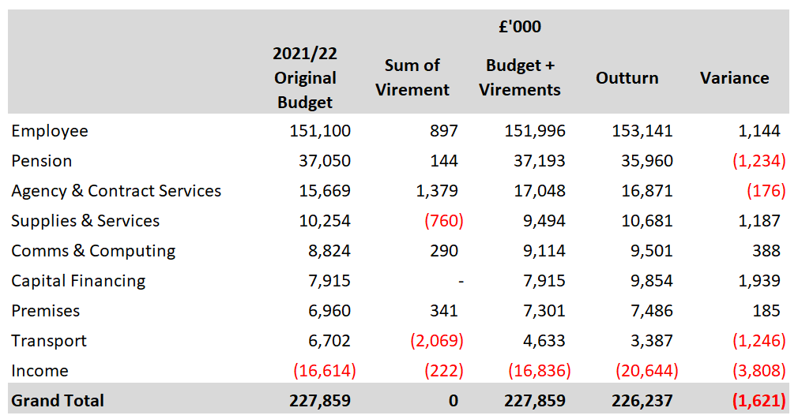

4.5 Each area is reported separately in section 5 below. The key highlights are:

- £3,213k overspend on police officer overtime, £1,326k of this is in respect of the unpredictable nature of the elected bank holidays, however some of the overspend is mitigated by (£813k) additional mutual aid income, (£588k) knife crime grant income, (£257k) covid income.
- Despite increasing the overall police officer numbers by 40 above the planned budget, the overall outturn shows a 0.15% saving against the budget, this is due to the timing of leavers which has been exceptionally high throughout the year.
- (£767k) savings on fleet adding to the savings reported in the previous financial year of (£353k) because of exit from the vehicle PFI (Public Finance Initiative) scheme.
- (£2,351k) savings achieved from staff pay and allowances due to high turnover of staff and inability to recruit. Contributing towards the overall cashable saving of (£7,314k) against a budget of (£2,500k).
- (£267k) housekeeping because of the finance department reviewing departmental orders.

5 Financial Implications and Budget Provision

5.1 Employee and Pension combined costs report an underspend of (£90k).

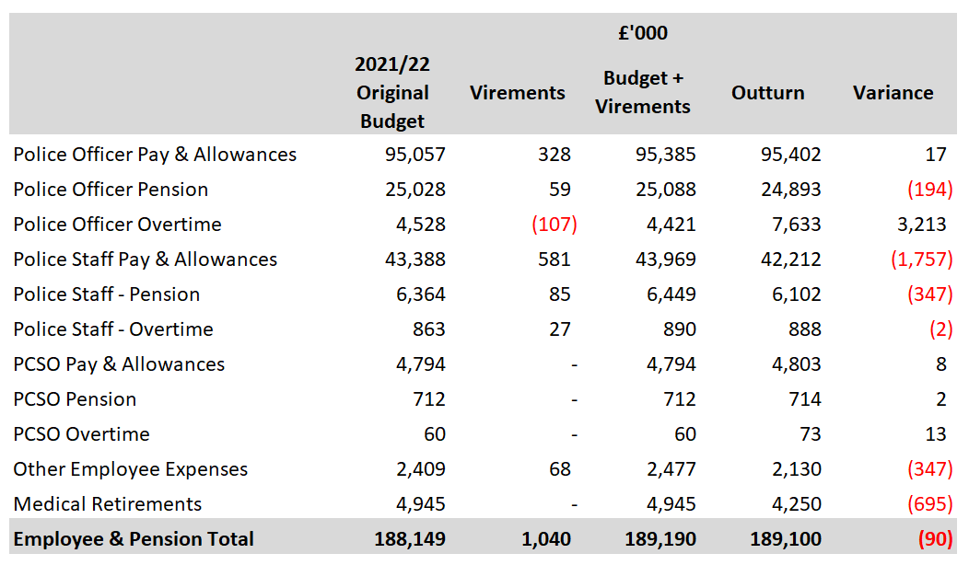

5.2 Police Officers Pay & Allowances.

The budget included 100 FTE uplift as part of the government’s 20,000 national increase in officers, this was increased to 140 which for Nottinghamshire is two years ahead of the government’s targets. The force was able to offset some of these costs by achieving 100% of the Home Office’s performance uplift grant.

5.3 The force is showing an underspend against officer pay & allowances and pension of (£177k), which is 0.15% of the budget. This is due to several factors including:

- Dynamic assessments of cohort start dates.
- Mix of rank of transferees.
- Considerably more retirements than planned these in the main are our 30 years + officers, therefore higher paid and of higher rank.
- The level of bonus payments was less than budgeted.
- The mix of ranks and acting of officers.
5.4 Police Officer Overtime

£3,213k overspend on police officer overtime, £1,326k of this is in respect of the unpredictable nature of the elected bank holidays, however some of the overspend is due to (£813k) mutual aid, (£588k), and (£257k) covid, which are offset with additional income through grants.

5.5 Police Staff Pay

Reports an overall underspend of (£2,106k), this is due to high staff turnover and difficulty in recruiting to vacant posts.

5.6 PCSO Pay & Allowances

The PCSO budget was based on an establishment of 150 FTE. The year started slightly higher at 153.35 FTE, by November this had increased to 155.31 FTE due to a cohort of 15 being recruited, the year ended at 143.67 FTE. This resulted in a slight overspend of £10k on pay and pension which is 0.18% of the budget.

5.7 Other Employee Expenses

(£193k) of this underspend relates to a provision made for redundancy payments, this was not required. (£45k) relates to delivery of external training courses, whilst every effort has been made to identify courses the back log of candidates created by covid has created a demand in this area. (£30k) recruitment cost underspend in respect of assessment centres.

5.8 Medical Retirements

(£695k) reduction in pension costs due to 15 medical retirements being budgeted and only 8 were realised during the year.

5.9 Agency & Contract Workers

Collaboration costs are less than expected due to a revised outturn position by region generating a saving of (£240k). (£300k) saving on funding regional ESN (Emergency Services Network) posts. (£245k) saving against MFSS (Multi Force Shared Services) mainly due to staff retention as forces exit the arrangement. Other costs/savings amounting to (£50k) reflecting changes within regional structures for Learning & Development and Prosecutions. These savings are offset with increase costs of £300k in collaboration as the funding formula cost share arrangement was not reviewed. £353k additional costs in relation to agency staff, this is to support the gaps within Police Staff as reported in section 5.5.

5.10 Supplies & Services

Costs are higher than expected due to insurance costs being £709k higher than expected, £246k increase in costs relating to recovery of vehicles, dangerous dogs and specialist consumable items, £200k increase in uniform costs in respect of the increase in officers above the budgeted number, £187k investments including, taser cartridges, targets, ammunition etc, radio frequency survey kit, drone capability, dive boat, SOC (Serious & Organised Crime) Surveillance kit and a contribution to SOCOTEC to expedite drug examinations. £107k increase in pathology fees and £54k increase in interpreters charges. These increases are offset in part by a (£224k) saving on legal fees and (£92k) saving on custody consumables.

5.11 Comms & Computing

Costs are higher than budgeted by £388k. This is due to investment in DEMS (Digital Evidence Management System), MFSS system replacements, laptops, mobile phones, and licences for the increase in officers and body worn video cameras for Authorised Firearms Officers. Savings have been realised from networks where lines have been decommissioned and more favourable rates achieved, a review of hardware requirements and licences was also undertaken.

5.12 Capital Financing

Costs are higher than budgeted due to an increase in the RCCO of £1,300k, this is a culmination of sale of write off vehicles (see decision record 2021.088) and in year opportunities to reduce future capital expenditure. £500k is allocated to the IT Reserve to off-set future years costs where supply chain issues will cause an unbudgeted impact. £217k a transfer from reserves was budgeted for purchase of vehicles which was not required. Transfer to reserves being the balance of the Speed Camera Project of £628k and ARIS (Asset Recovery Incentivisation Scheme) £97k. A withdrawal from Police Property Act Fund of (£49k) to facilitate the removal of property across the force. (£499k) reduced MRP costs, (£255k) increase in investment interest.

5.13 Premises

Premises costs show an overspend of £185k, this is in respect of utility costs £71k, rent/rates £40k, cleaning £85k and £11k general increases across other estates areas, the increases are in respect of Bridewell which was retained longer than budgeted, costs for New Custody being higher than expected, and a pension charge in respect of the cleaning contract. This was offset by an increase in income for reduced rent for Phoenix House, EMAS Carlton and Hucknall. Reduced reactive maintenance costs as the planned works for Byron House did not go ahead.

5.14 Transport

Transport shows an underspend of (£1,246k). A gross saving of (£1,211k) has been recorded across the fleet areas of maintenance, repairs, and tyres, this has partly been offset by additional costs in employee and capital financing resulting in a net saving of (£767k) because of exit from the vehicle PFI scheme. (£250k) saving due to not replacing speed camera vehicles, and (£25k) contamination cleaning, these savings are offset with additional costs in respect of fuel £132k, insurance £83k and mileage expenses £25k as travel restrictions are lifted.

5.15 Income

Additional income of (£3,808k). (£1,699k) has been generated throughout the year, this is in respect of knife crime, stalking protection orders, armed response, cybercrime, witness care, Covid and ARIS. A further (£813k) has been generated through mutual aid assistance to other forces which includes COP26 and G7. (£405k) has been realised through charging for additional seconded officers. (£270k) from additional partnership income. (£233k) aerial income, (£245k) vehicle recovery, and (£107k) apprentice incentive. Much of the additional income is offset with costs in other spend areas, particularly officer overtime.

5.16 Efficiency savings. The original budget identified that savings of £2,500k needed to be achieved to reach a balanced budget for 2021/22. These were met as detailed in the table and where exceeded are due to in year underspends as well as efficiencies. Some underspends were reinvested in year.
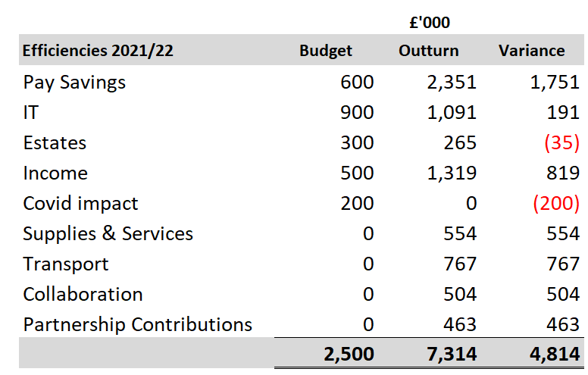

- (£2,351k) underspend achieved from staff pay and allowances due to high turnover of staff. As an organisation we need to become more diligent in understanding the processes for recruitment, ensuring we maximise timescales to prevent this underspend occurring in the future. The underspend equates to 80 staff posts not being filled every month of the year, which in turn creates performance and welfare issues for those in post.
- IT savings of (£1,091k) have been generated from networks where lines have been decommissioned and more favourable rates achieved, review of hardware requirements and licences.
- Estate’s savings mainly because of expected inflation rises not being as much as anticipated during the financial year.
- (£1,319k) more income generated than expected in relation to vehicle recovery, incident reports, aerial rental, apprenticeship incentive payments, partnership funding and loan charges grant.
- Within supplies and services (£300k) was realised as the regional funding for ESN was not required this financial year.
- Transport savings have been reported in section 5.6 of this report.
- Collaboration savings include the revised outturn position reported by the Region.
- Partnership contribution savings include (£408k) savings in respect of reduced IT charges from the Home Office.

6 Human Resources Implications

  - There are no immediate Human Resource implications arising from this report.

7 Equality Implications

  - There are no equality implications arising from this report.
8 Risk Management

8.1 There are no risk implications arising from this report.

9 Policy Implications and links to the Police and Crime Plan Priorities

  - There are no policy implications arising from this report.

10 Changes in Legislation or other Legal Considerations

10.1 There are no changes in legislation or other legal considerations that are relevant to this report.

11 Details of outcome of consultation

11.1 The figures included in this report are presented to the Force Executive Board monthly.

12. Appendices

12.1 There are no appendices to this report.

13. Background Papers (relevant for Police and Crime Panel Only)

NB
See guidance on public access to meetings and information about meetings for guidance on non-public information and confidential information.

