For Information
Public/Non Public* | Public
Report to: | Accountability Board
Date of Meeting: | 12th July 2022
Report of: | Mark Kimberley
Report Author: | Tracey Morris
E-mail: | Tracey.morris@notts.police.uk
Other Contacts: | Danny Baker
Agenda Item:

Capital Outturn Report 2021/22

- Purpose of the Report

  - The purpose of this report is to provide the financial outturn position for capital for 2021/22.

- Recommendations

  - Recommendation 1
It is recommended that the contents of the report are noted.

  - Recommendation 2
It is recommended that slippage requests summarised in Appendix A and raised as a separate decision record are approved.

- Reasons for Recommendations

  - To update on the Force’s outturn position for 2021/22 and to comply with good financial management and Financial Regulations. To support the request for slippage of budget into 2022/23 to enable projects to continue to completion.

- Summary of Key Points

  - The capital budget is £28,360k, outturn at the end of 2021/22 is £18,811k, generating an underspend of (£3,804k) and (£5,744k) which is requested as slippage into 2022/23.

  - The budget has grown since approval as follows:
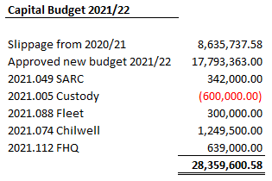
  - Summary by department.
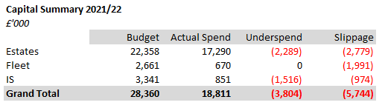

4.4 Each area is reported separately in section 5 below. Overall, the force has spent 66% of the budget.

4.5 The key highlights are:

Supply chain issues have played a major part in the slippage requests for all projects, those that have underspend are in the main due to costs being realigned to revenue.

5 Financial Implications and Budget Provision

5.1 Estates

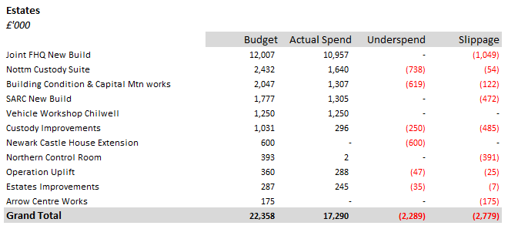
Slippage has been identified and requested by Tim Wendels, Head of Estates & Facilities.

5.2 Joint FHQ New Build
A 4-year project to construct a joint headquarters for Fire and Police on the existing Police headquarters site. The original budget for the project was agreed at £18,500k, following receipt of tenders for the new build works which came in lower than expected the budget was reduced by (£639k). Since that time, additional costs have arisen, the result is that it is necessary to reinstate the original capital budget by adding back the £639k, this has been approved by the OPCC and the change reflected within the P9 figures. Whilst the building is operational there are still some costs to be incurred as part of the overall project.

Slippage is requested for £1,049k

- There are fees to be paid to Henry Brothers for contract retention totalling £387k,
- There is a £200k risk allowance still allocated within the budget,
- General furniture, fixture and fittings allowance is £123k,
- The remainder £339k will contribute towards the costs of the phase 4 works.
5.3 Nottingham Custody Suite
A 4-year project to purchase land and construct a new custody suite. The original budget for the project was approved at £17,825k, whilst there has been some rephasing of the budget across the years the project was completed in September 2021 on time with an underspend of (£738k).

Slippage is requested for £54k

- Fees payable to Perfect Circle £4k which relate to a retention, payable 10 months after the completion of the project.
- There is also a risk allowance of £50k relating to the road issues with the landowner, £20k of this is a retention from the land purchase. Some of the landowners’ responsibilities relating to the road have not yet been fulfilled and it is possible that the Police will have to complete certain additional works and seek to reclaim any costs above £20k from the landowner.
5.4 Building Condition & Capital Maintenance works
Comprised of several projects, the programme reflects the risks identified within the building condition survey. Most projects are on track, works to alter accommodation at Mansfield has been completed. A saving of (£619k) has been achieved.

Slippage is requested for £122k

- £10k to complete Oxclose Roof & Windows. Supply issues of materials have caused a delay.
- £112k in respect of Mansfield Lighting, supply issues will mean a delay to April 2022.
5.5 SARC New Build
A multi-year project to build a new SARC on existing land. The budget for the project was approved at £1,192k.

Slippage is requested for £472k

- The construction work has been delayed because the foundations had to be redesigned due to the ground conditions being worse than expected, there have been delays on delivery of internal doors due to manufacturing delays. The consequences of this has meant that the construction work is two months behind schedule, and this will delay the transfer of services from the existing building to the new building. Slippage is requested to pay for construction work, fees, contractor retention, furniture, and IT.
5.6 Vehicle Workshop Chilwell
A decision record was approved to increase the capital budget by £1,250k for the force to acquire the vehicle workshop at Chilwell previously part of the Venson contract. The completion date for the purchase of the workshop was 25/11/21.

5.7 Custody Improvements
Comprised of 3 projects that aim to ensure the custody suites are maintained to a suitable standard, works have been undertaken at Mansfield and Oxclose Lane. £250k budget was included for possible site separation of the Bridewell from the Magistrate’s Court, as the Magistrate’s Court purchased the property no separation was required resulting in an underspend.

Slippage is requested for £485k

- £475k requested for replacement of CCTV and cell call systems and the charge desk at Mansfield. This work has been delayed because of limited procurement resources and delays to full agreement of the scope of the work and the designs.
- £10k requested for additional construction works to carry out late changes made by the A&E Team, the Oxclose Lane works are nearly completed, and the funding of the additional work will enhance the facility and will still be implemented before the A&E team relocate.
5.8 Newark Castle House Extension
This project was cancelled in lieu of a decision made by the PCC.

5.9 Northern Control Room
For resilience purposes it was agreed to complete works at Mansfield Police station to convert the existing NCR into a dual-purpose training facility and reserve control room.

Slippage is requested for £391k

- The work was initially delayed because of Covid and then it was considered that the closure of the NCR couldn’t take place until the new HQ Control Room was in operation and tested over a couple of months.
- Slippage is to cover the cost of construction work, fees, and furniture.
5.10 Uplift
Comprised of several smaller projects designed to accommodate the Forces increase in Officers and Staff, works are planned for an extension to the dog kennels, relocating to DEIU into stores, and a new transformer for FHQ.

Slippage is requested for £25k

- Slippage is in relation to the Dog Kennel Extension and is required to cover the cost of additional works to the existing and newly provided kennel compounds. Lead times are such that the works cannot be delivered on site until April due to the additional manufacturing time required for bespoke items.
5.11 Estates Improvements
Comprised of several smaller projects designed to ensure best use is made of the space available to the Force. Works include building alterations to Phoenix House and works within the CSI area to comply with UKAS accreditation.

Slippage is requested for £7k

- The CSI alteration works have been completed, but the contract allows us to retain a percentage of the value of the work for 12 months after the completion of the works and then to pay the contractor the retention, which is due at the end of August 2022, assuming there are no faults.
5.12 Arrow Centre Works

A decision notice has been signed by the OPCC to move some of the existing Estates capital budget where projects are underspending to create a new budget for works to be carried out on the labs at the Arrow Centre. The full cost of these works is to be funded by EMSOU.

Slippage is requested for £175k

- The design, tender and works could not be achieved in 2021/22 due to the agreement to proceed with the project not being given early enough, the works have been tendered and works will commence May 2022.
5.13 Fleet

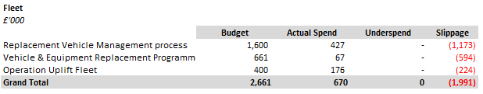

Slippage has been identified and requested by Mark Kimberley, Head of Fleet.

5.14 Three projects which result in the replacement and growth of fleet vehicles within the force.

Slippage is requested for £1,173k

- This slippage request covers the intended base vehicle acquisitions that have not been purchased due to the below contributing factors:
  - Massive delays with delivery of the vehicle purchasing framework
  - Manufacturers withdrawing from the vehicle purchasing framework
  - Supply chain issues for the building of cars (semi-conductor shortage)
By not fully delivering 2021/22 assigned vehicle replacements means that on top of the 2022/23 vehicles there will be additional vehicles to replace. This will, in turn, increase the cost of repairing our older vehicles and put a greater demand on the vehicle workshop. Without fully completing a financial year’s assigned replacement vehicles means there is potential to have a ‘snowball’ effect where the number of vehicles requiring replacement continually increases year on year.
Slippage is requested for £594k

- This slippage request covers the vehicle conversions and additional equipment such as gun boxes outside of the base vehicle purchases. With not being able to purchase all the required base vehicles in 2021/22 we have not been able to convert the vehicles as required. Contributing factors are listed above.
Slippage is requested for £224k

- This slippage request covers the intended implementation of the new telematics system within 2021/22. The project started in November 2021 and is due to be fitted to 485 vehicles but due to the civil engineering works being carried out at the Chilwell workshop the end date of the hardware installations has been pushed back by at least 3 months.
5.15 Information Services

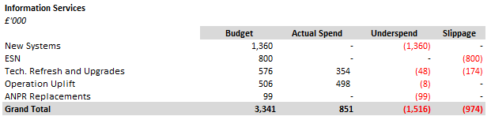

Slippage has been identified and requested by Julie Mansfield, unless otherwise stated.

5.16 New systems
This budget was for the replacement MFSS system, which has since been funded from revenue.

5.17 ESN
No progress on this national project.

Slippage is requested for £800k requested by Tracey Morris

- Since 2015 a capital budget has been identified for this project, which has been rolled forward year on year. The overall impact on capital is still somewhat unknown and an inflation amount continues to be added to the capital programme to keep the budget in line with original expectations.
5.18 Tech. Refresh
Comprised of several smaller projects designed to replace hardware in Information Services.

Slippage is requested for £174k
- Due to the global microchip shortage, the supplier has not been able to fulfil the order to deliver the equipment for the force wide polycom replacement project or the desktop equipment for the FHQ. IS were able to recycle stock from elsewhere in the business to ensure the building is operational.
5.19 ANPR
The full budget for ANPR reflects an underspend due to a review of the purchases being made and ensuring a consistent accounting approach. The purchases are being accounted within the revenue budget.

6 Human Resources Implications

  - There are no immediate Human Resource implications arising from this report.

7 Equality Implications

  - There are no equality implications arising from this report.
8 Risk Management

8.1 There are no risk implications arising from this report.

9 Policy Implications and links to the Police and Crime Plan Priorities

  - There are no policy implications arising from this report.

10 Changes in Legislation or other Legal Considerations

10.1 There are no changes in legislation or other legal considerations that are relevant to this report.

11 Details of outcome of consultation

11.1 The figures included in this report are presented to the Force Executive Board monthly.

12. Appendices

12.1 Appendix A – Capital Slippage request.

13. Background Papers (relevant for Police and Crime Panel Only)

NB
See guidance on public access to meetings and information about meetings for guidance on non-public information and confidential information.

Appendix A

Slippage Requests 2021/22

