Thematic Reports: SUPPORT:

C1: Improving Outcomes for Victims of Crime and ASB – Hate Crime

HATE CRIME

Victims of Hate Crime in Nottinghamshire receive an enhanced service. Divisional hate crime Inspectors carry out early reviews of all hate crime cases to provide oversight and ensure appropriate progression for each case. Our dedicated hate crime team audit all hate crimes and non-crimes and carry out welfare calls to victims between 10 and 20 days following the incident. The hate crime team liaise with the Officer in the Case should there be any queries or concerns from the victim and further support and signposting to services is completed. The Research and Insight team also contact victims of hate after 2 months following report for a more in-depth satisfaction survey. In our most recent survey in February 2022 victim satisfaction for the whole experience of hate crime was 80.8%.

The hate crime team also attend community engagement events supporting different strands of hate crime and work in partnership with numerous private, public and third sector organisations, focussing on encouraging reporting and training for staff.

The figures below illustrate that hate has increased to higher levels than before the pandemic. Recorded hate crimes have increased every month over the previous 6 months when compared to the same months in 2018-19. Recorded hate non-crimes have decreased overall, however increased in May 2022. All strands of hate have increased, other than religion/faith and misogyny, which have reduced.

While it is a long-term aspiration to reduce hate crime, the short to medium term aspiration is to increase reporting, reflecting improved knowledge of hate and reporting mechanisms within our communities and increased trust and confidence in Nottinghamshire Police.
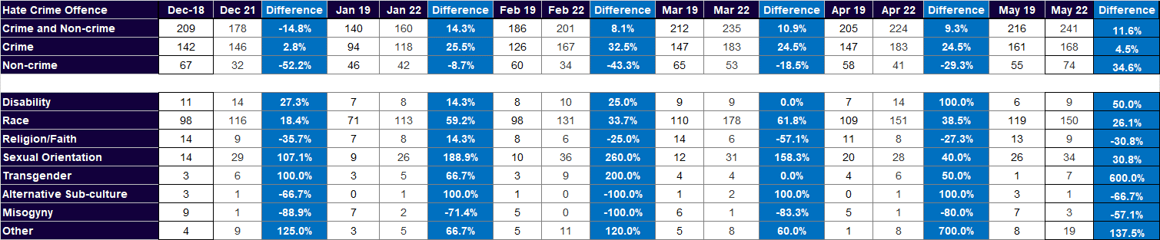
The above figures are taken from Crime & Outcomes; sourced from Niche via Business Objects. Crime Groups are as per the Home Office Crime Tree.

Positive outcomes have increased in recent months, compared to the same period prior to the pandemic. May 2022 is the anomaly to this however, which saw a reduction in positive outcomes for hate crime when compared to May 2019 and when compared to previous months in 2022. The Out of Court disposal team now regularly interact with the hate crime leadership team and partake in hate crime performance meetings with the objective of improving positive outcome rates for hate crime. There are many occasions in which a positive outcome could be achieved, for example community resolutions or cautions, when there may not the evidence to progress to a criminal prosecution.

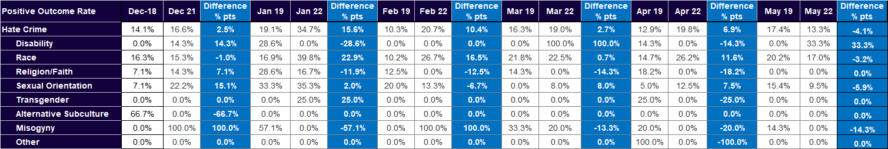
The above figures are taken from Crime & Outcomes; sourced from Niche via Business Objects. Positive Outcomes are Rated by Class of Offence and include: 01 Charge/Summons; 02 Caution-Youth; 03 Caution-Adult; 04 TIC; 06 Penalty Notices for Disorder; 07 Cannabis Warning; 08 Community Resolution.

Charging rates for hate crime vary greatly, with different strands of hate swinging drastically due to relatively low numbers for each. In the last 6 months the lowest charge rate was in May 2022 with 63.6% and the highest was April 2022 with 80.6%. Charge rates for misogyny are an anomaly as this is not a national strand, but a local strand of hate and therefore will not be charged on its own. Where charges exist for misogyny the case was charged as an alternative offence, with misogyny hate crime also being an element of the case. It is important to note that our current policy does not ask officers to include misogyny hate in cases such as domestic abuse and sexual crimes against women.

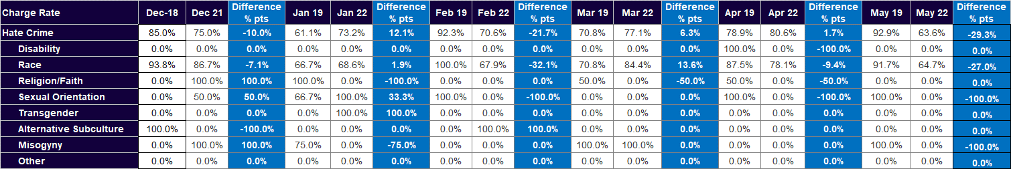
The above Hate Crime figures are taken from Crime & Outcomes; showing 01 Charge/Summons outcome as a proportion of all positive outcomes for Hate Crime and sub-categories.
Detections and Charge Rates
Provided below is the outcome data up to 27th June 2022.

The following are a number of highlights/headlines:

- Outcome performance has not yet recovered to the pre-pandemic levels – although the trajectory of recovery continues.
- The data demonstrates clearly that both in terms of volume and rate, the current years performance is out stripping 2021/22 perfomance.
- Rape and sexual offences are seeing improved outcomes when compared to both 20/21 and the base year of 19/20.
- Both categories of robbery are also achieving better outcomes than each of those previous years.
- A similar picture can be seen with hate.
- Shoplifting outcomes are recovering. The volume of outcomes now far exceeds last year. However, given the increase in shoplifting volume the rate is still lagging slightly.

To 27/6/2022 |  | To 27/06/21 |  | To 27/06/19
All Crime  3,515 | 13.7% | 3,056 | 13.4% | 4,136 | 15.9%
Victim Based  2,306 | 10.8% | 1,771 | 9.5% | 2,690 | 12.3%
VAP  1,100 | 12.8% | 836 | 10.1% | 1,158 | 14.1%
VWI  486 | 16.8% | 329 | 13.0% | 624 | 19.4%
VWO  412 | 12.8% | 346 | 11.5% | 372 | 14.3%
Rape  25 | 8.1% | 15 | 5.7% | 10 | 3.5%
Other sexual  71 | 11.2% | 48 | 9.0% | 68 | 12.4%
Bus Robbery  14 | 42.4% | 2 | 10.0% | 9 | 37.5%
Personal  58 | 27.9% | 17 | 9.7% | 30 | 10.7%
Dwelling  64 | 7.5% | 46 | 6.1% | 83 | 7.2%
Commercial  28 | 7.0% | 25 | 9.1% | 41 | 7.6%
Theft person  21 | 7.9% | 8 | 4.0% | 15 | 4.1%
Bike  4 | 1.1% | 10 | 2.9% | 16 | 3.0%
Shop  530 | 18.9% | 418 | 20.1% | 781 | 29.1%
Domestic Crime  443 | 11.0% | 352 | 10.2% | 535 | 15.9%
Hate  86 | 20.3% | 72 | 12.7% | 61 | 14.5%

Provided below is the most recent outcome data for comparison against the region and our MSG – up to end of April 2022 .

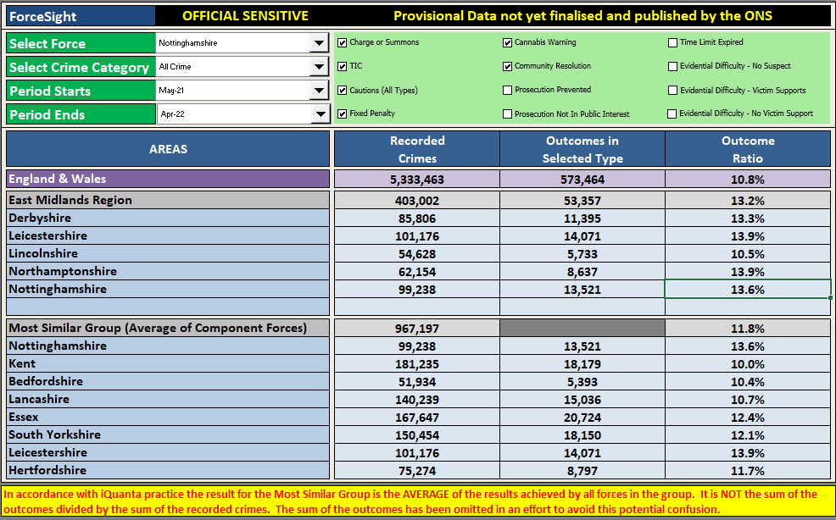

Approach/oversight relating to outcome performance:

Scrutiny around outcomes has been elevated over the course of the last 12-18 months and as a result we have been enjoying a trajectory of improving performance.

Our approach has to been to focus on the quality of investigation, whilst at the same time, providing some additional governance via our Operational Performance Review (chaired quarterly by the ACC Crime) and our CJ Board (chaired quarterly by ACC Crime.)

The MoJ CJ Score card has focussed our scrutiny even further and the data shared through this route is examined on a monthly basis and helps to drive improvement activity.

Our approach to outcomes has been further augmented through the following:

Improving Investigations Group (IIG)

This meeting is chaired by the Head of Crime (Chief Det Supt Gary Hooks). The purpose of the group is to improve the quality of investigations across the force. It comprises of staff from all areas of investigation including Public Protection/Criminal Investigation Department/Serious and Organised C/PHT) and specialist areas (Managing Information/Crime Registrar).
The quality of investigations, measured against the standards set out in our investigation procedure, are monitored through a schedule of audits which report to the IIG to inform improvement activity including training and development opportunities for our staff.

Task and Finish Group

It was identified from the IIG meeting that different business areas had differing working practices/expectations. The T and F Group was set up to ensure a consistent high standard across investigations. The results from this group informed the below document.

Investigation Procedure

The force has recently updated the Investigation Procedure to address issues identified following the Crest report. The document covers key areas such as the level of investigation/allocation of staff/expectations on Officers in Charge (OIC) and supervisors/training etc.

Supervisory responsibilities

The Investigation Procedure provides supervisors with clear expectations across both PIP1 and PIP2 investigations. This document has been approved by Chief Detective Superintendent Hooks (Head of Crime) and has been circulated across all areas of investigation. The procedure is available on the intranet.

Approach to OOCD

The pandemic presented the force with an opportunity to examine its approach to OOCD – and the learning has resulted in a more appropriate and proportionate approach to outcomes. This has provided a solid platform for our transition to the new statutory “two tier” approach to OOCD, which the force is implementing via a new OOCD Board, with a timeline set for end of March 2023.

