For Information / Consideration / Comment / Decision (delete as appropriate)
Public/Non Public*
Report to: | Accountability Board
Date of Meeting: | 9th August 2022
Report of: | Mark Kimberley
Report Author: | Tracey Morris
E-mail: | Tracey.morris@notts.police.uk
Other Contacts: | Danny Baker
Agenda Item:

Capital Outturn Report 2022/23 as at the end of June.

- Purpose of the Report

  - The purpose of this report is to provide the financial outturn position for capital for 2022/23 as at the end of June.

- Recommendations

  - Recommendation 1
It is recommended that the contents of the report are noted.

- Reasons for Recommendations

  - To update the Force Executive Board on the Force’s outturn position for 2022/23 as at the end of June, and to comply with good financial management and Financial Regulations.

- Summary of Key Points

  - The capital budget is £12,387k, outturn at the end of 2022/23 is £12,325k, generating an underspend of (£62k).

  - The budget has grown since approval as follows:

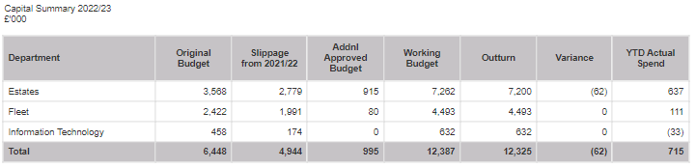

4.3 Each area is reported separately in section 5 below

4.4 The key highlights are:

Supply chain issues continue to give concern to delivery of the projects.

5 Financial Implications and Budget Provision

5.1 Estates

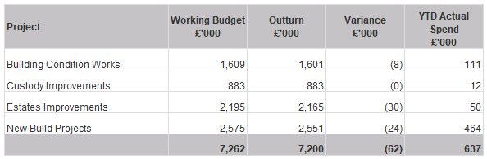

5.2 Building Condition Works
Comprised of several projects, the programme reflects the risks identified within the building condition survey. Most projects are on track.

5.3 Custody Improvements

Comprised of 2 projects that aim to ensure the custody suites are maintained to a suitable standard, works are due to start at Mansfield and Oxclose Lane.
5.4 Estate Improvements

Comprised of several smaller projects designed to ensure best use is made of the space available to the Force. Works include conversion of the stores and printing area into suitable office accommodation; environmental improvements; Arrow Centre office and car park alterations and works at Mansfield Police station to convert the existing NCR into a dual-purpose training facility and reserve control room which has been delayed for a number of years.

5.5 New Build Projects

Phase 4 of the Joint FHQ Build is underway, converting the old control room into useable office/training facilities. Final snagging works and release of final payments in respect of the Nottingham Custody Suite. Finishing touches and final payments in respect of the new SARC.

5.6 Fleet

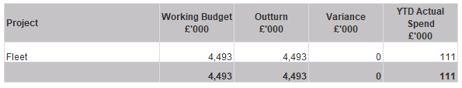

5.7 Three projects which result in the replacement and growth of fleet vehicles within the force. Purchases and deliveries are now being made in an effort to catch up on supply chain issues from last financial year.

5.8 Information Services

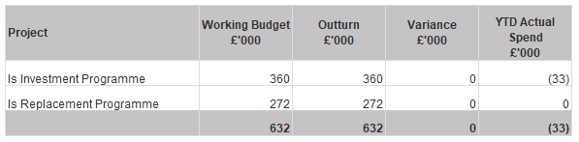

5.17 IS Investment Programme
Includes OPCC investment for safe haven cameras and ANPR. There is also a small budget for ESN works.

5.18 IS Replacement Programme
Comprised of an ongoing budget for replacement of static ANPR cameras and replacement video conferencing equipment.

6 Human Resources Implications

  - There are no immediate Human Resource implications arising from this report.

7 Equality Implications

  - There are no equality implications arising from this report.
8 Risk Management

8.1 There are no risk implications arising from this report.

9 Policy Implications and links to the Police and Crime Plan Priorities

  - There are no policy implications arising from this report.

10 Changes in Legislation or other Legal Considerations

10.1 There are no changes in legislation or other legal considerations that are relevant to this report.

11 Details of outcome of consultation

11.1 The figures included in this report are presented to the Force Executive Board monthly.

12. Appendices

12.1 Appendix A – Detailed Project Table.

13. Background Papers (relevant for Police and Crime Panel Only)

NB
See guidance on public access to meetings and information about meetings for guidance on non-public information and confidential information.

Appendix A

