JOB DESCRIPTION

Job title: Chief Executive and Monitoring Officer (CEO)

Department/Location: Office of the Police and Crime Commissioner (OPCC)

Responsible to: Police and Crime Commissioner (PCC)

Responsible for: Five direct reports

Date: June 2024

JOB PURPOSE

To provide overall management, leadership and strategic direction to the OPCC and support the Police and Crime Commissioner in their statutory duty to secure an efficient and effective police service for the Nottinghamshire Police area.

To discharge the statutory defined duties of the Chief Executive Officer of the OPCC as defined by legislation, including being the Head of Paid Service and exercising the role of Monitoring Officer to ensure an efficient and effective Office of the PCC.

PRINCIPAL ACCOUNTABILITIES

1. | To advise and support the PCC on their strategic priorities and to lead on the delivery of those priorities. To ensure the efficient and effective delivery of the Police and Crime Plan, together with any associated delivery plans.
2. | To ensure provision of appropriate and timely advice and briefings to the PCC and provide leadership and strategic direction to support the PCC in discharging their statutory powers, duties and procedures.
3. | On behalf of the PCC, develop and lead positive, collegiate relationships with key partners, Nottinghamshire Police and the Chief Officer Team, to drive the delivery of key priorities including those in the Police and Crime Plan.
4. | Responsible for statutory compliance including financial (alongside Chief Finance Officer), audit, equalities and diversity and management of strategic risk and information management.
5. | To provide clear and visible leadership to the OPCC including staff development, support and training.
6. | To undertake the role of Monitoring Officer and notify designated officers/bodies of any illegality or maladministration in relation to the business of the OPCC.
7. | To keep abreast of changes in legislation, case law, statutory and non-statutory guidance and other relevant publications; advise the PCC on impending legislation, national policy and oversee the PCC response to consultation documents.
8. | To ensure the OPCC fully meets its statutory and other obligations including the maintenance or formal records, processes and appropriate standards.
9. | To set and drive implementation of the OPCC corporate strategies, and ensure that the office delivers an excellent service to the public, that effective accountability arrangements are in place to enable the OPCC to monitor, review and improve its own performance in order to deliver continuous improvement.
10. | To lead the senior management team of the OPCC, ensuring the effective development and delivery of strategic plans, scrutiny, commissioning and engagement with the communities of Nottinghamshire and Nottingham City.
11. | To support the PCC to develop their influence and profile at a local, regional and national level, including any national portfolios undertaken by the PCC.
12. | Develop and maintain external relationships at a senior executive level with partners, organisations and stakeholders at a local, regional and national level and to support the PCC in developing positive political relationships.
13. | To oversee arrangements for the appointment of Chief Constable, including their terms and conditions of service and matters relating to discipline.
14. | To take responsibility for identifying your own professional and career development needs and to undertake regular appraisals of your staff and responsibility for helping to address their professional and career development needs.

DIMENSIONS

Financial: Accountable for c£15m
(OPCC, VRP, Commissioning and Grants)

Staff: Five direct reports (plus Chief Finance Officer)

Sphere of activity:

Plan, organise and implement activities on a short, medium and long term basis at a strategic level.

Other:

Reporting directly to the Police and Crime Commissioner, the CEO is expected to head up the Senior Leadership Team in the OPCC, comprising ‘Heads of’ functions and the Chief Finance Officer.

The post-holder will have an influential and convening leadership role that extends far beyond the OPCC, into Nottingham Police and the wider partnership landscape locally and regionally including local authorities, regional police forces and criminal justice agencies. In addition, the role has national profile through the APCC and APACE, as well as working with MoJ and Home Office officials.

ORGANISATIONAL/DEPARTMENTAL CHART

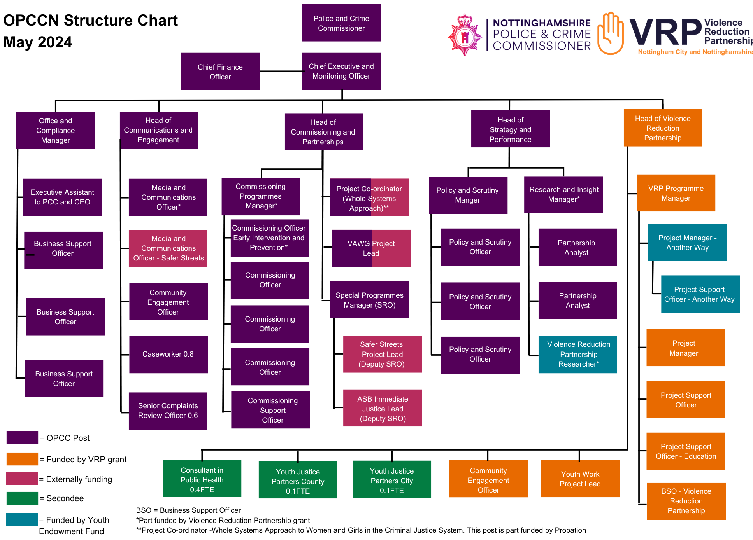

PERSON SPECIFICATION

Job title: Chief Executive and Monitoring Officer (CEO)

Department/Location: Office of the Police and Crime Commissioner

Date: June 2024

CRITERIA | ESSENTIAL | DESIRABLE | METHOD OF ASSESSMENT
KNOWLEDGE AND EXPERIENCE  - Previous experience of leadership and operational management as a CEO in an OPCC.  - Proven track record of leading significant strategic development and operational delivery  - Experience of working at a strategic level with partnership organisations and multi agencies  - Experience of change management  - Experience of working with statutory and compliance bodies |  |  | Application form/Interview  Application form/Interview  Application form/ Interview  Application from/Interview  Application from/Interview
SKILLS AND ABILITIES  - A progressive and inspirational leader that sets the vision, engages people and delivers  - Exceptional presentation, verbal and written skills to multiple stakeholders  - Ability to demonstrate effective negotiating, influencing and engagement skills  - Must be diplomatic and tactful and able to maintain strict confidentiality in a politically sensitive environment  - Ability to positively influence a broad spectrum of people at all levels of an organisation including multi agency partnerships, external bodies and members of the public  - Ability to produce management information and reports and to present to a variety of target audiences  - Planning and organisational ability to manage a high workload and balance competing priorities  - Ability to analyse and interpret complex information and situations and give clear, objective and impartial advice based on this.  - Ability to carry out horizon scanning and to anticipate future requirements whilst adapting in response to evolving issues  - A proactive, innovative and confident problem solver |  |  | Application form/Test/Interview  Application form/Interview  Application form/Interview  Application form/Interview  Application/Interview  Application form/Interview  Application form/Interview  Application form/Interview  Application form/Interview  Application form/Interview
EQUCATION/QUALIFICATION  - Educated to degree level or similar in a relevant discipline  - Masters level qualification in a relevant discipline |  |  | Application form  Application form
OTHER  - Able to demonstrate a personal commitment to equality, diversity and inclusion  - Willing to undertake vetting to the required level (management level) for the post  - Must be able to routinely travel to locations across the county and occasionally outside the county  - Possess a flexible approach to meet the demands of the workload |  |  | Application form  Interview  Interview  Application form/Interview

